Business Question and Visualization Report
Team ID | MCA
Project Name | Smartphone Usage, Digital Addiction & Well-Being Analysis
Maximum Marks | 5 Marks

Visualization development refers to the process of creating graphical representations of data to facilitate understanding, analysis, and decision-making. The goal is to transform complex datasets into visual formats that are easy to interpret, enabling users to gain insights and make informed decisions. Visualization development involves selecting appropriate visual elements, designing layouts, and using interactive features to enhance the user experience. This process is commonly associated with data visualization tools and platforms, and it plays a crucial role in business intelligence, analytics, and reporting.
Business Questions and Visualization
The process involves defining specific business questions to guide the creation of meaningful and actionable visualizations in Power BI. Well framed questions help in identifying key metrics, selecting relevant data, and building visualizations that provide insights.
Business Questions and Visual Mapping Table
 | Business Question | Visualization Type & Description | Artifact Requirement
1 | How does the average daily screen time differ across genders? | Column Chart (Average Daily Screen Time by Gender): Compares average daily screen usage among Male, Female, and Other gender categories. | 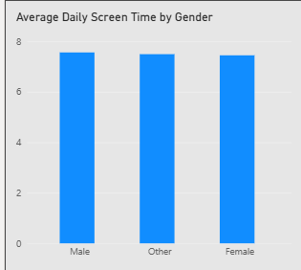
2 | What is the distribution of users across different levels of device addiction? | Horizontal Bar Chart (Users by Addiction Level): Ranks the volume of users categorized by behavioral levels such as Moderate, Severe, Mild, and None. | 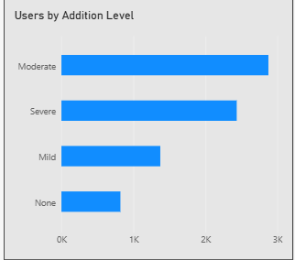
3 | Which age group exhibits the highest average daily screen time? | Column Chart (Average Daily Screen Time by Age Group): Displays usage trends segmented by demographics like 26-35, 18-25, and Under 18. | 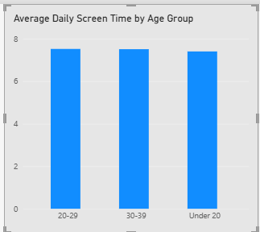
4 | Is there a visible relationship between a user's daily screen time and their sleep duration? | Scatter Plot (Daily Screen Time vs Sleep Hours): Plots individual data points to analyze the density and distribution between screen activity and rest hours. | 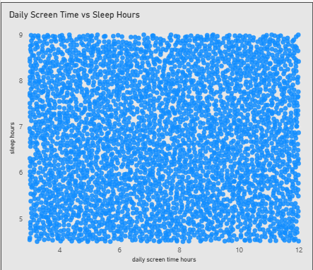
5 | What proportion of the surveyed population is classified as addicted vs. non-addicted? | Donut Chart (Addicted vs Non-Addicted Users): Breaks down the total user base (7.5K) into percentage shares based on clinical addiction status flags. | 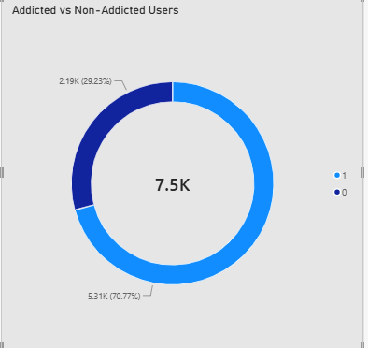
6 | How does the time spent on gaming compare directly against social media application usage? | Clustered Column Chart (Average Gaming vs Social Media Usage): Juxtaposes the average daily hours spent on mobile games vs social networking platforms side-by-side. | 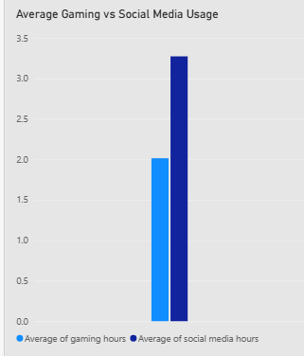
7 | How do interactive dashboard filters impact the user distribution views dynamically? | Slicers (Addition Level, Gender, Age Group): Provides dynamic drop-down controls allowing users to isolate demographics and cross-filter all dashboard visual cards. | 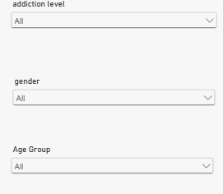
8 | What is the total size of the sample population surveyed in this study? | Card Visual / Total Center Label: Displays the high-level summary metric of 7.5K total unique users tracked in the model. | 